# 1.8 Laser monitoring system

Figure .1  ***Scheme of the Laser monitoring system. TO BE UPDATED***

In order to monitor in a more continuous way than with the source, the variations of the scintillator transmittance and of the APD gains, a Laser system has been designed, following a scheme similar to the one used for the CMS calorimeter [ref.xx]. Due to the fact that solar blind photo-sensors from RMD are selected, a unique wavelength, where the sensor has reasonable quantum efficiency, is used. The laser light is brought by a distribution system and optical fibers on the readout side of the detector. The fibers’ end has a ferrule connector that will be positioned in between the two photo-sensors and blocked by a small screw in a reproducible way. The light transmitted through the crystal, and then reflected and diffused by the crystal and the wrapping material, illuminates the active area of the photo-sensor. As shown in Fig.xx of sec.xx, an upper limit for the detectable light is at ~ 270 nm. Deterioration of the crystal transmittance due to the irradiation is usually concentrated at the lowest wavelengths and can be controlled by the source response assuming a tight control of the photo-sensors’ gain. We are evaluating different options for a laser emitting DUV light between ~ 220 and 260 nm.

A scheme of the overall system is shown in Figure 0.1. A high precision, high power, pulsed laser sends light through standard collimation optics to an optical splitting system, done with mirrors, to subdivide the beam in 12 equalized parts. By means of 12, 1 mm diameter quartz, 20 m long fibers, the light is brought to the DS bulkhead and then, through Vacuum Feed-through, to the back face of the disks. On each disk mechanical structure, there are 6 integrating sphere of 2” diameter with one input for the incoming

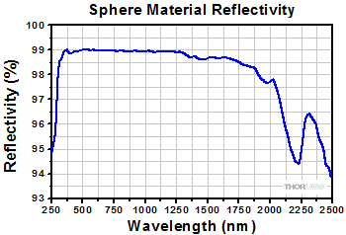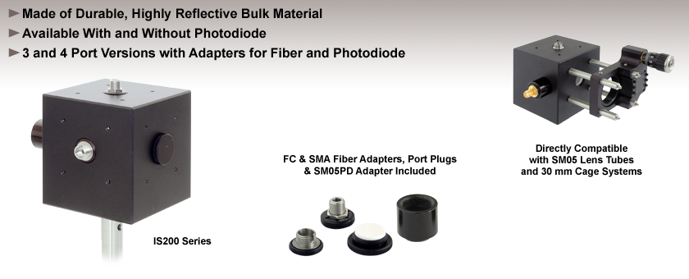

Figure .2 *(Left) Picture of the ThorLab IS-200 sphere used for the prototype, (right) reflectivity dependence on the Wavelength.*

beam and two outputs. In each output, there will be a bundle of 100 fused silica fibers, 200(250) μm core(cladding) diameter, granting a total of 1200 fibers/disk reaching the APD’s area. Details on the integrating sphere, on the fiber bundles and on the transmission losses are shown below when describing the prototype assembled for the Lyso crystal matrix. Out of the 1200 fibers/disk, 930 are used for gain calibration, 48 for monitoring while the remaining 222 are replacements in case of fiber cracking during handling or installation.

The monitoring system is based on the readout by means of pin-diodes of the: (i) output light from the laser, (ii) the returning light from the integration spheres. A total monitor of 50 channels is needed. Requirements for the monitoring systems are that of tracking pulse amplitude variation larger than 1 %, so that the precision of the pin-diode and of the readout system should be able to monitor variations at a level of 0.5%. The selected laser-head and the monitor boxes will be thermo-stabilized, to reduce the laser variation to few % and make the pin-diode associated correction small.

In order to monitor the calorimeter response linearity, a neutral filter wheel, with gradually changing absorption values, is inserted between the primary beam and the light distribution system.

There is not a stringent requirement on the laser pulse width, since the APD readout electronics has a rise time between 6 to 8 ns thus setting a width upper limit to 10 ns. Similarly, the running frequency is not strongly constrained since, as shown in the prototype test, running at 1 Hz grants a better than per-mil statistical precision in one hour data taking. It is instead mandatory to synchronize the laser pulsing with an external trigger to allow the light to reach the detector in the correct time window with respect to the gate and/or to the empty beam period when required. The laser pulse energy is strongly reduced by the distribution system. However, since the laser signal should simulate a 100 MeV energy deposition, in the BaF2 case this corresponds to require ~ 10.000 pe for each photo-sensor. This roughly corresponds to 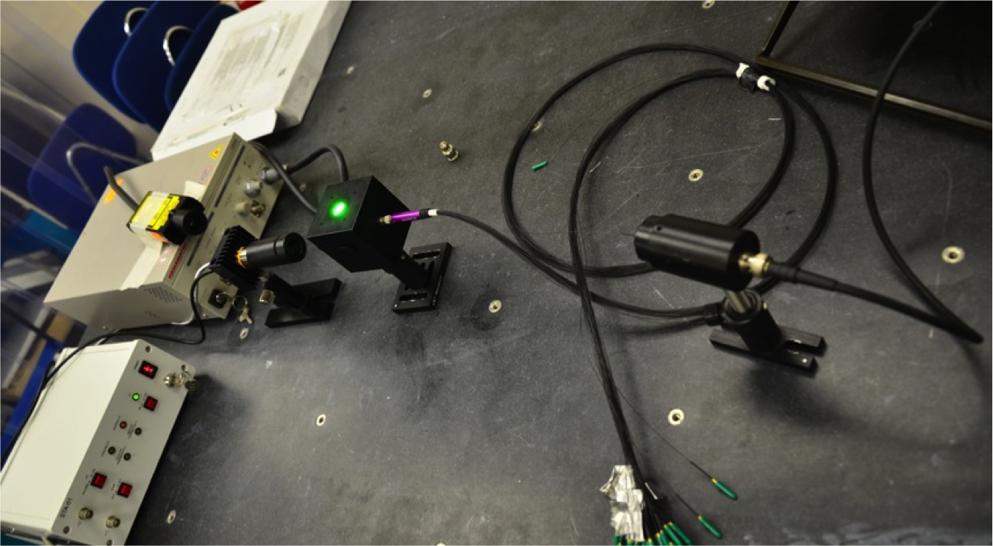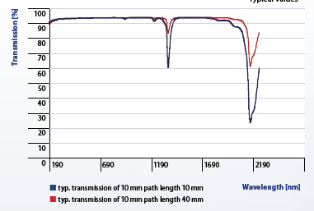have ~ μJ energy for pulse.

Figure .3 (Left) transmission as a function of wavelength for the fused silica fibers and (right) picture of the light distribution system prototype.

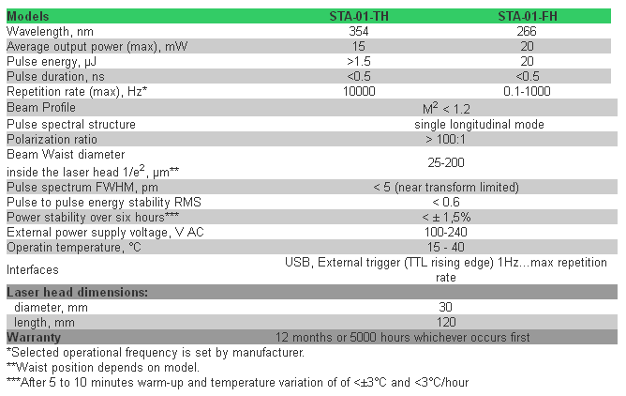A stringent requirement is on the type of fibers that should have a high transmittance at 200-260 nm, a small attenuation coefficient and should be radiation hard up to O(100 kRad). The best choice is to use fused silica fibers both for their transmission properties (see Figure 0.3.left), that grants an almost flat dependence down to 150 nm, and for the reasonable attenuation length and the high radiation hardness.

Figure . *Main properties of the STANDA Lasers operating in the UV region*

# 1.8.1 Laser monitor prototype for the LYSO crystals

The setup used for the transmission test and for the calibration of the Lyso calorimeter prototype is shown in Figure 0.3.right. As light source, we used the solid-state pulsed laser STA-01 emitting at 532 nm that offers a pulse energy of 0.5 muj, < 1 ns pulse width, a good pulse-by-pulse (3%) stability and can be triggered externally for frequencies up to 100 kHz. Tab.XX summarizes the performances for equivalent STA-01 laser emitting on the UV. The distribution system uses a 2” integrating sphere, the ThorLab-IS200, with one input port and 3 output ports, each one of 0.5” diameter. Pictures of the sphere and of its reflectivity diagrams are shown in Figure 0.2. An Hamamatsu Pin-Diode S1722-02 is mounted in one of the sphere port to monitor the laser pulse variation, while a bundle of 2 m long *Leon*i fused silica fibers of 200 mum diameter, is inserted with an SMA connector to an other port.

We have tested the system in 2 ways: (1) measured the transmission in one of the output ports and (2) the transmission at the end of the fiber bundle. This has been done as follows. We measured: A,B. At the end of the fiber bundles we measured an attenuation ..

We have then repeated the test inserting the fibers in the calorimeter system and measured the number of photoelectrons and the … as in the final configuration.

**1 page more with description of the plots.**